First Wyoming History Day, Rock Springs, May 1, 1981*
* Wyoming students participated in National History Day for the first time in 1980, but the state competition was held regionally that first year.
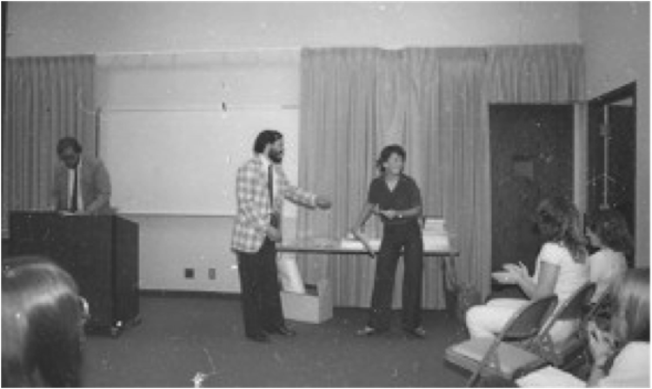
﻿Dr. David Kathka (left) announces a winner at Wyoming's first-ever Wyoming History Day (1981) while Phil Roberts (center in the checkered jacket) hands an award to an unidentified History Day student﻿.

﻿﻿

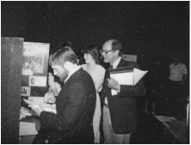
﻿﻿History Day judges Chris Plant (left), Mary Mayfield, and Bill Barton score an exhibit during judging in the first-ever Wyoming History Day, held at Rock Springs on May 1, 1981.

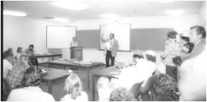
﻿History Day organizers welcome students, teachers and judges to the first History Day. (Peggy Bieber-Roberts photos)

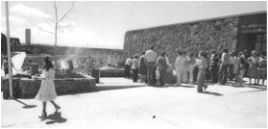
History Day participants, judges and teachers enjoyed a barbecue outside at Western Wyoming College prior to the awards ceremony. (Peggy Bieber-Roberts photo)

