JFK Campaigned for Democrats in Wyoming in 1958
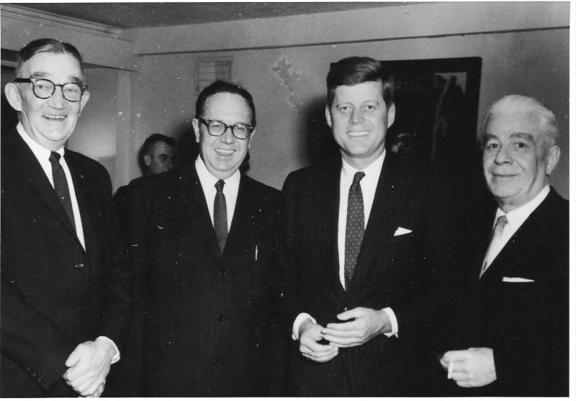
Three Wyoming Democrats are pictured with then-Sen. John F. Kennedy in this photograph probably taken in 1958 when Kennedy was campaigning in Wyoming on behalf of various Democrats. Shown, left to right, are: Jack Gage, J. J. "Joe" Hickey, JFK, and Tracy McCraken. Gage won election later that year as Secretary of State while Hickey was elected governor. McCraken, long-time publisher of the Wyoming Tribune-Eagle, was State Democratic chairman. Gertrude Johnson collection, Wyoming State Archives.

