DAY 3 (June 15, 2016) Crook County Sites

The entire day was spent viewing sites in Crook County, the third northeastern county on our itinerary. Crook County once comprised the entire northeastern corner of Wyoming, including what is now Weston County and Campbell County. It was created in 1875 (organized ten years later) and named for Gen. George Crook.
We traveled to the Vore Buffalo Jump and spent the morning viewing it. Dr. Charles Reher met us at the site and described how the sinkhole formed, from the gypsum soil eroded and creating a 40-foot deep, 200-foot wide depression at the top of a short hill. Dr. Reher said that the site proved ideal for trapping bison by the Indians who, in those times, did not have horses. The animals were enticed to the top of the hill and then run over the top where some 200 at a time would fall into the hole. Below, other Indians would be waiting to finish off bison that lived through the fall and then to butcher them for meat. The entire harvest had to be carried out of the hole and away from it a mile or so to the nearest stream where the tribe would be encamped. Dogs helped do the hauling. The site, named for the ranchers who homesteaded on the location in the 19th century, is operated by a non-profit foundation. In the past 15 years, the volunteer group has constructed two buildings, one resembling a teepee. Visitors view the jump from above and then follow a paved path around it to the bottom where a roof encloses the dig site itself. Archaeological teams led by Dr. Reher over the years have uncovered numerous layers, including many generations of Indian use of the jump. The bone remains of thousands of bison and various stone tools have been found among them. The work continues.
The bus drove us over to Aladdin for lunch at Cindy B's. Aladdin is the closest town to the lowest elevation in Wyoming--3,100 feet where the Belle Fourche River flows out of Wyoming and into South Dakota. Business activity is brisk in the summers when bikers stop en route to the Sturgis Motorcycle Rally each year.
We left for Devils Tower after lunch, traveling through the small towns of Alva and Hulett. The latter place has a state-of-the-art lumber mill as well as an airport and a golf course. (Unfortunately, this writer often has mistaken Alva with Alta, another small town on the west edge of the state almost in Idaho).
On arrival at Devils Tower, the bus fell into line behind dozens of other cars awaiting admission to the nation's first national monument. Buses must unload passengers and then park on a lower level from the visitor center and the tower. After disembarking, we assembled under the canopy across the street from the visitor center where Ranger Joe Bruce, education technician, gave us some information about the Tower, including the recent controversies over possible renaming to "Bear Lodge" and the voluntary agreement to respect Native American traditions by not climbing the tower during the month of June. The tower was first climbed on July 4, 1893, by two local ranchers, William Rogers and Willard Ripley, as a part of a Fourth of July celebration at the tower's base. They made the climb by wooden pegs driven into cracks. For the next several decades, other climbers used the ladder to make the climb. When the two men reached the summit, they unfurled a 12-foot American flag. When it ripped apart by the high winds later that day, it was cut into pieces and sold to the public. Rogers' wife became the first woman to climb the tower when she used his peg "ladder" later that month.
As early as the 1890s, the General Land Office (GLO) received applications for homestead entry including Devils Tower in the land to be claimed. Pressures mounted as individuals tried to come up with ways to commercialize the site. Finally, President Theodore Roosevelt utilized his new-won power, given by him from Congress through the Antiquities Act, to declare Devils Tower as America's first national monument. (Ironically, in 2015, Wyoming is the only state where a President is specifically denied the authority to create a national monument without full Congressional approval).
In early October 1941 South Dakotan George Hopkins, a professional parachutist, accepted a bar bet that he could land on top of Devils Tower. He intended to have a rope dropped with him in order that he could descend, but even though Hopkins hit the target on top, his rope didn't. For the next six days, as rain and 50 mph winds buffeted the top of the tower, Hopkins waited for a rescue crew. His story became international news. He was eventually rescued by climbers. Although little of the film was actually shot at Devils Tower, the Tower was the main feature in Steven Spielberg's popular film, Close Encounters of the Third Kind (1978).
Several travelers completed the walk around the tower's base, but from all indications, none attempted an ascent during the two hours we visited the site!
Our travelers stopped in downtown Sundance to view the "Sundance Kid" statue on the courthouse square. Many had seen the piece before on earlier trips, but the guide noted that while Laramieites know "a lot about Butch Cassidy because of his incarceration" in what is now the prison in Laramie's Territorial Park, few know much about Harry Longabaugh and how he gained his nickname, the "Sundance Kid." Doing time in the Crook County Jail provided his nickname (and, apparently not wanting to be known as the "Crook Kid," he adopted the name of the town where the jail was located).
The group continued on to Ranch A. The impressive log structure with numerous outbuildings is located south of Beulah in a picturesque valley. (Unfortunately, due to county replacement of most of the bridges along the creek, the beauty of the scene was difficult to appreciate). Nonetheless, on arrival at Ranch A, the manager of the property, Annette, met us and gave us a brief tour. Mo Annenberg, a Chicago publisher of the Racing Form, visited the area about 1927. Legend has it that he stopped at Beulah for lunch and had a dinner of trout. He asked where the trout came from and, when told from the creek south of town on a ranch, he bought the ranch on the spot for some $27,000. There, he decided to build his summer home. The log lodge designed by South Dakota architect Ray Ewing, and outbuildings were constructed for $300,000 in 1932-33. Annenberg hired Thomas Molesworth to completely furnish the place in his distinctive furniture style. In 1936, while Mo Annenberg was fishing at the lodge, he heard about the possible sale of the Philadelphia Enquirer and, from the phone at the lodge, is said to have finalized his purchase of the paper. In 1940, Mo Annenberg was convicted of income tax evasion, sent to prison, and died two years later. The property was sold to offset the tax bill. (Annenberg's son, Walter Annenberg, had few ties to the Ranch A. He later founded TV Guide magazine and became U. S. Ambassador to Britain in the Nixon administration. His foundation endowed journalism schools at USC and the University of Pennsylvania, and continues to support public television programming). Former Wyoming Gov. Nels Smith and two partners purchased the property and ran it as a dude ranch for the next 20 years. In 1963, the federal government bought back the ranch and established a fish hatchery at the site, transferring title to the State of Wyoming in 1996. A non-profit, the Ranch A Restoration Foundation, manages the property for the state as an education center. The lodge was placed on the National Register in 1997. For much of its existence as a lodge, dude ranch and fish hatchery headquarters, the ranch featured the Thomas Molesworth furniture. Currently, most of the pieces have been transferred to the Wyoming State Museum and the Crook County Museum, located in the courthouse, (but soon to open a new two-story operation in what had been the Sundance grade school across the street from courthouse square). Molesworth light fixtures still provide the lighting for much of the lodge and the main room retains the same general character as when it was constructed. Travelers had an opportunity to visit with several students who were part of a summer field program from South Dakota School of Mines using the lodge for several weeks in the summer. Annette noted that the lodge is open from April-early October and, in future, may open for private events such as weddings and reunions.
From Ranch A, the trip returned to Beulah and to the Buffalo Jump Saloon where a dinner of either steak or salmon was served. Following dinner, Dr. Reher hosted the group for a short visit to his new home, a refurbished historic flour mill, south of Beulah.
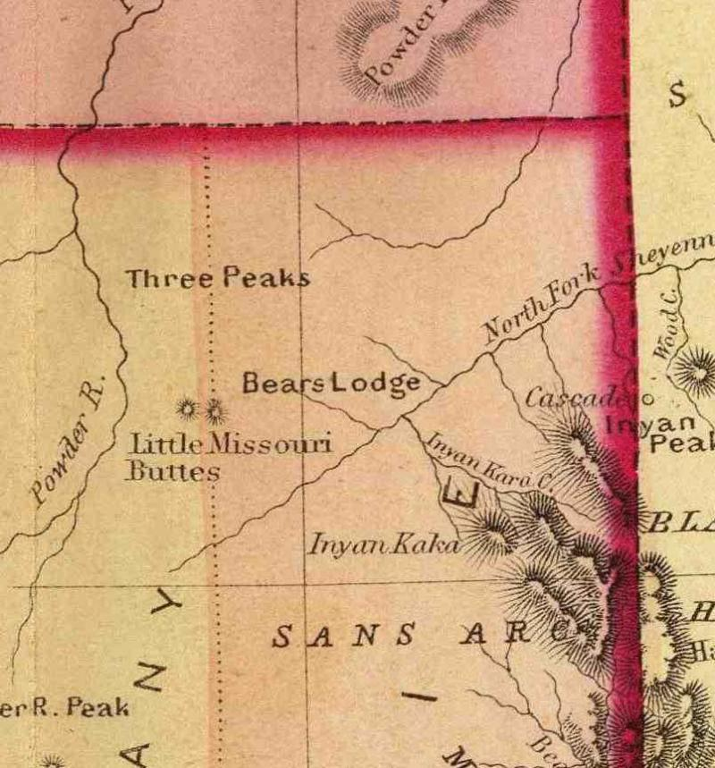This section of the 1872 General Land Office map of Wyoming shows "Bears Lodge," the original Lakota name. Due to a bad mis-translation, it became Devils Tower in the 1880s. An effort to correct the name and go back to the original is now underway.

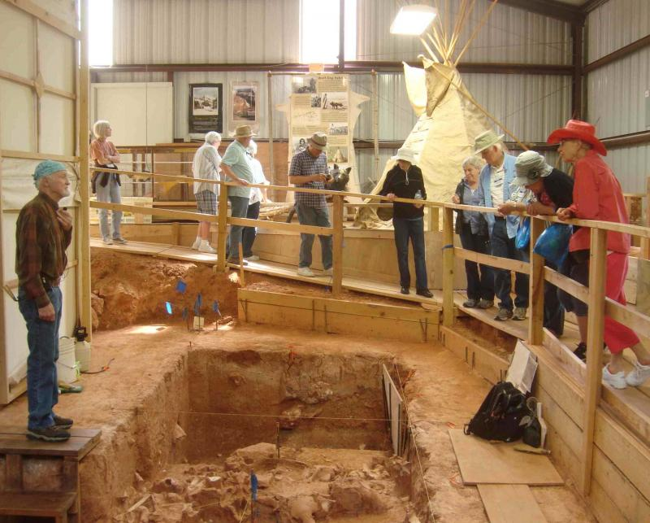Dr. Charles Reher explains the archaeological layers of bison bones and tools uncovered through various digs at the base of the Vore Buffalo Jump. Phil Roberts photo
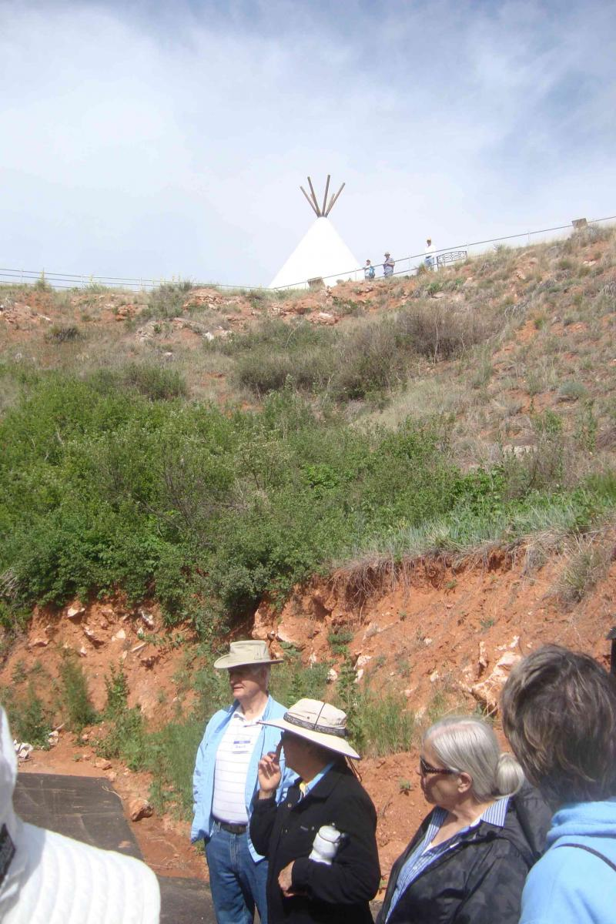
Our travelers walked down the trail from the visitor center at the top of Vore Buffalo Jump down to the dig level.
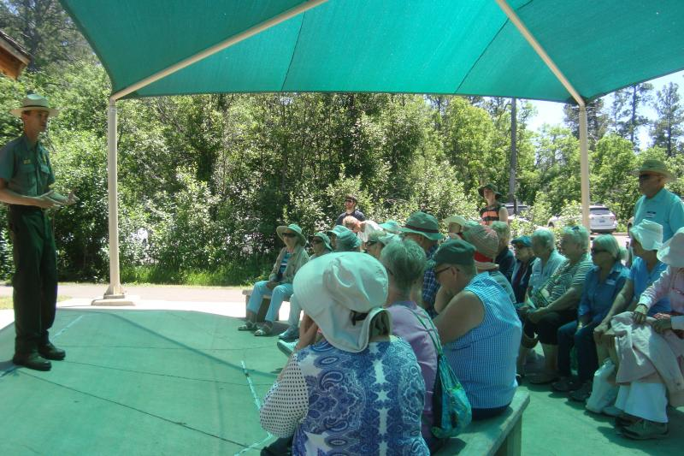
Ranger Joe Bruce spoke to our group at the base of Devils Tower, explaining some issues of name-changes and June suspensions of climbing.
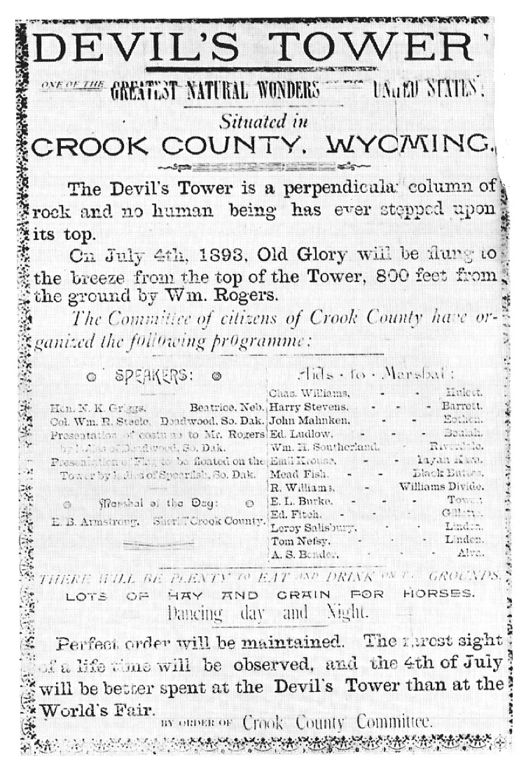
The tower was climbed by two area ranchers during the 4th of July celebrations in 1895. This ad appeared in a local newspaper prior to the event.

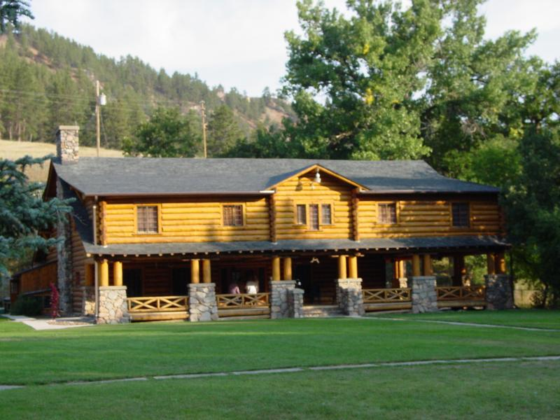
Ranch A main lodge, south of Beulah. Phil Roberts photo
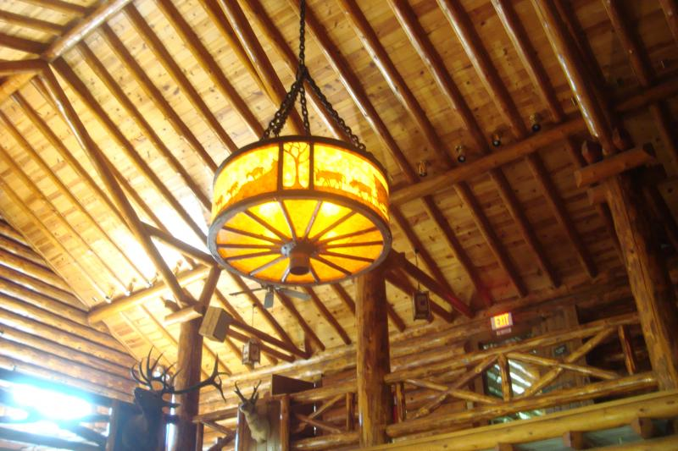
The light fixture designed and made by Thomas Molesworth, main room of Ranch A.
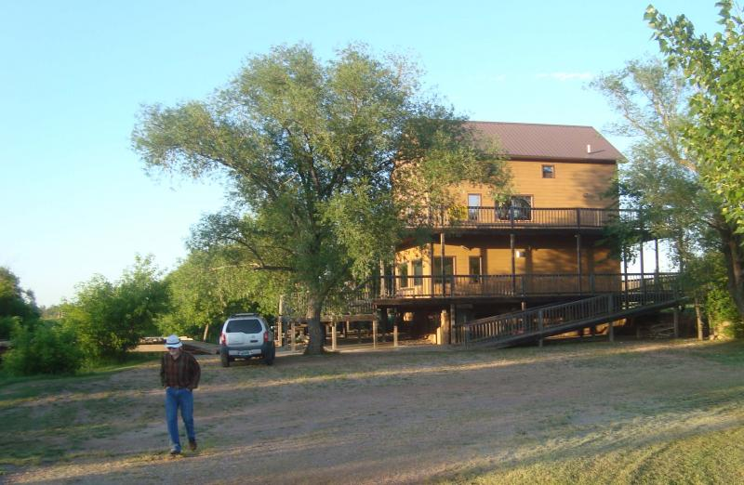After dinner in Beulah, Dr. Reher (pictured) invited the group to view his home, once a flour mill and restored as a private residence.

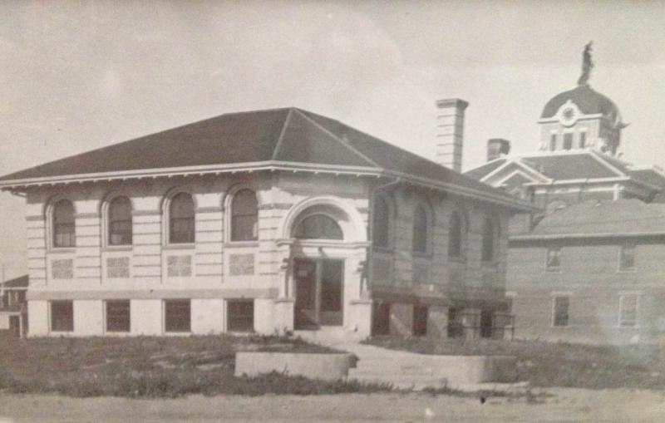
The Carnegie Library in Lusk retains its original character, even with a significant extension added to the east of the building in the 1980s. The Niobrara County Courhouse, pictured at the back right, is shown with the statue of blind justice atop its cupola. The statue had to be removed when it was determined that the roof could not sustain the load. (Roberts family photograph)

DAY 4: (June 16, 2016) Campbell County Sites
Campbell County was one of seven Wyoming counties formed in 1911 during the greatest county expansion in state history. It was made up of the western halves of Crook and Weston counties. Initially, in the territorial period, the area was included in Albany County when the five original counties stretched from the Colorado line to the Montana border.﻿
After enjoying the bison barbecue with all of the fixings, the group paid a final visit to the gift shop and returned to the hotel, concluding the Campbell County day.﻿
Primary activity in the morning was a guided tour of a coal mine--the Eagle Butte mine north of Gillette. Yet another "Phil" was the local guide! A former long-time employee of Alpha Natural Resources, the owners of the Eagle Butte mine, Phil knew a good deal about mining around Gillette. He described the current situation in the coal fields as dire although it appeared that mine operations were continuing and coal was being extracted from the open-pit surface mine and loaded onto cars of a unit-train.
Eagle Butte shipped its first coal in 1978, the same year that two other mines near Gillette started: Jacobs Ranch and Caballo. The first surface mine in the area (and in the state of Wyoming) was the Wyo-Dak mine, just east of Gillette that began producing coal in 1924. (Underground coal mines along the Union Pacific line in southern Wyoming opened much earlier. Carbon, the first operating coal mine in Wyoming, began operations in 1869, the year Wyoming was organized as a territory). For many years, the Black Thunder mine, south of Gillette, led in annual coal production. It first opened in 1977.
Like many of the other mines in Campbell County, the Eagle Butte mine is located on federal land, under lease from the BLM. Homesteading patterns in the county were established by the earlier dominant industry, livestock grazing. What once had been public lands open to grazing by any stock company was opened to homesteading soon after the CB&Q Railroad laid tracks through northeastern Wyoming. (The town of Gillette is named for Edward Gillette, one of the engineers responsible for surveying the line). Little interest came from farmers, even during the heyday of "dry farming" in the 1890s and early 1900s. After Congress passed the Stock-raising Homestead Act of 1916, livestock grazers gained an interest in making claims. The act did not require bringing water to the land, like the Desert Land Act of 1877 required, nor did it contain any requirement for growing trees or crops. It allowed claimants to use the land for grazing cattle. Because the act assumed that the surface was sufficient for livestock endeavors, the federal government retained the sub-surface rights. This "split estate" (one entity owning the surface, another owning what was below the surface) was irrelevant until the 1970s.
Ranchers knew coal, of a low quality, existed under their lands, but few considered that it would have commercial use at any time in the future. In the early 1970s, tests revealed that Powder River Basin coal, while producing less energy per ton as other coals in the country, contained far less dangerous levels of sulfur and other impurities. It was the "cleanest coal" in the United States. (Eagle Butte coal contains from .3-.6 percent sulfur). Soon after, the Arab oil embargo caused energy prices to skyrocket. Suddenly, the lesser quality coal became economically desirable for electric power plants to burn. The Nixon administration had created the EPA and, in Wyoming, the Hathaway administration established the Department of Environmental Quality, along with passing laws limiting emissions from coal-fired plants. These environmental laws proved fortuitous for Wyoming coal. Suddenly, huge strip mines opened. Ranchers owning the surface, but not the subsurface, often accepted cash payments from coal companies for the land, the royalties to the subsurface going to the federal government who had retained the subsurface rights. Other ranches that gained ownership of the surface and sub-surface either leased their lands for hefty royalty payments or sold for huge sums. The coal boom was on. Six huge mines opened by the end of the 1970s; three more went on line by 1990.
The Alpha Natural Resources guide admitted that conditions were not near as favorable in coal prices and demand now. (The company, in fact, filed for chapter 11 bankruptcy protection on Aug. 3, 2015, in Virginia. The firm had 8,000 employees in both eastern and western mines. The firm hammered out a deal with disgruntled creditors in the fall of 2015, in order to reorganize debt of some $4 billion. The federal bankruptcy judge accepted the company's plan on May 25, three weeks before our visit).
The 240-ton haulers were hauling the 2-million tons a month still coming from the mine, to the tipple where coal was loaded onto 100-ton railroad cars loading below at a rate of one 120-car train every two hours. Some 60-65 trainloads are shipped out daily, down from the peak of some 85 trains at the peak several years ago.
In the 1970s, the county population soared. In 1960, only 5,861 people lived in the entire county. By 1980, the number was 24,367. Gillette, a cattle-raising center with few paved streets in the 1950s, became a roaring boom town. Just 2,191 people lived in Gillette in 1950 (about the same number as in Lusk and 1,500 fewer than in Newcastle). The population sign on the edge of town indicates a current population in excess of 34,000, making it similar in size to Laramie. (The official 2010 census showed Laramie with a population of 30,816; Gillette, 29,087).
After noon lunch in the park , the trip continued to the Rockpile Museum. According to the museum's history homepage: "The Rockpile is a natural sandstone formation. It was used as a landmark for cattle drives to recognize proximity to Burlington Lake, where they could water and graze their cattle while waiting for shipment on the railroad. Four employees of the Burlington and Missouri Railroad (C. T. Weir, Frank Murrey, and Robert & George Durley) were the first to file homestead rights in Rockpile Draw (to the northeast of the rockpile near the present train depot) in March 1889. These were later purchased by the Lincoln Land and Livestock Company which planned the town and sold lots in 1891."
The museum contains artifacts from every era in the county's history. Gillette was founded in 1891 as a railroad stock-loading town. As late as the 1950s, the main industry was sheep and cattle raising. Many artifacts in the museum reflect these early origins. In the early 1950s, the south part of the county experienced a uranium boom near Pumpkin Buttes. Oil discoveries had been made in various parts of the county from the 1920s to the 1970s. The major industry in the 20th century was coal mining. The first surface mine in Wyoming, the Wyo-Dak (noted above) was opened in 1924, but the coal boom started in 1974. The museum building was constructed in the early boom years with a new building now being planned for the near future.
After the museum tour, the bus carried travelers south to the Durham Buffalo Ranch, just north of Wright.
The 60,000 acre ranch has been owned and operated by the Flocchini family since 1965. We were met at the ranch headquarters by John Flocchini who directed the bus down ranch roads about five miles to the northwest part of the place where the herd of some 3,000 bison were grazing. John cautioned that viewers needed to remember that John would have to be between them and the bison at all times. Many of the cows had beside them the new calves, born in April and May. The bus returned to the ranch headquarters where travelers visited the gift shop, drank from the cash bar or shot photographs while the buffalo steak barbecue was being prepared. John told about the history of the ranch and described some of the unique qualities of bison. The family-owned ranch sends buffalo for meat-processing to a packing facility near Denver where the meat is shipped to the business' main headquarters, the Sierra Meat Company, in Reno, Nevada. From there, the meat is cut into steaks and other cuts and then distributed to stores in the West. "In a snowstorm, they always face into the wind," he said. Unlike cattle who face away and then tend to drift, bison remain in place, the fine hairs around their eyes and nostrils making it possible to keep from suffocation from blowing snow. They wait until the storm is over, shake their coats of the snow, and go on their way, he told the group.
The family business began in 1934 when Armando Flocchini, Sr., bought the San Francisco company, founded in 1890, where he had worked. He brought his sons in as partners. Over the years, the third generation family members took various roles in the firm, John managing the ranch operations in Wyoming. The ranch was named for the short-horn cattle breed, Durham, that had been raised on the place. The family business' corporate headquarters in San Jose, Calif., was bought by a housing developer in 2001. Since the firm had owned Sierra Meat Company in Reno since 1986, it shifted its headquarters and many of its operations there.
﻿
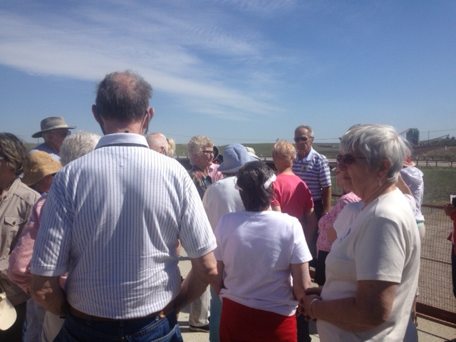Travelers began Day 4 of the tour with a visit to the Eagle Butte coal mine, north of Gillette. They were overrun that day by people named "Phil"--the driver, the historian, and the mine guide all had that name! (Phil Roberts photo)
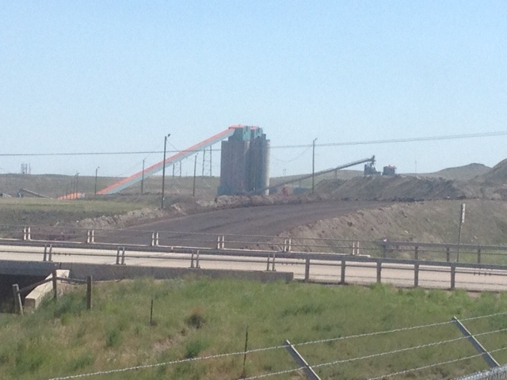
Eagle Butte mine, north of Gillette, June 2016.
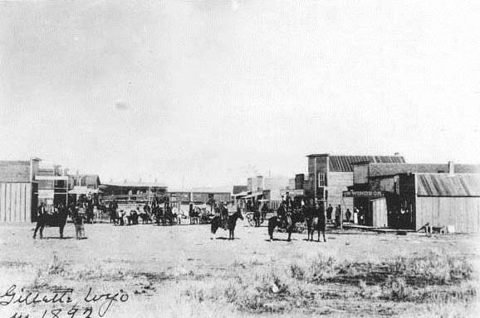
Gillette in 1892, the year following its founding. (Courtesy Rockpile Museum, Gillette)
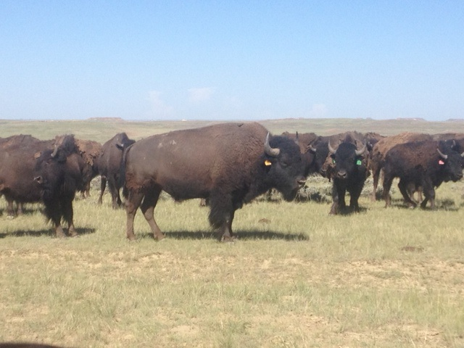
The Durham ranch has a herd of some 3,000 bison.
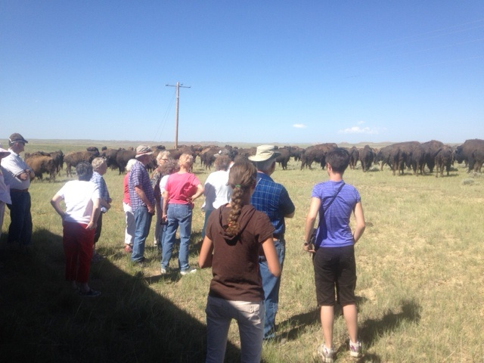John Flocchini, the ranch manager, showed the visitors the ranch herd of some 3,000 bison. (Phil Roberts photo)
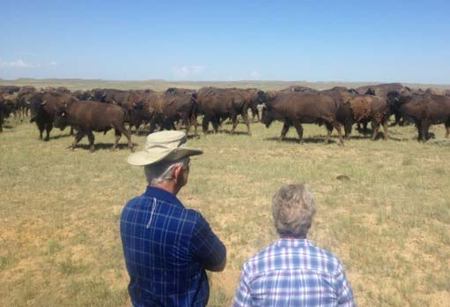

DAY 5: Travel Day Home
﻿A couple of planned stops were scheduled for the 5th day of the trip, but the primary endeavor was returning to Laramie from the northeast part of the state.﻿
After lunch of pizza and drawings for door prizes, the bus tour continued home via the Manville-Guernsey cut-off. After a brief stop in Hartville, where some travelers visited what was billed the "oldest bar in Wyoming," the group arrived back at the Spring Creek School parking lot in Laramie about 3 p.m. All were inspired by the courage and strength of our friend Germaine who rode the entire way from Hartville to Laramie with what turned out to be a broken hip.﻿
Rattlesnake stories told by Mary entertained the bus passengers as we were leaving Newcastle. She told of forays to hunt rattlers and the demonstrations made by her family members of effective "snake tools." While the northeastern part of Wyoming is "snake country," rattlesnakes are almost entirely absent around Laramie (even though they are found in the Sybille Canyon area, some 30 miles northeast of town). Snake experts believe that rattlesnakes do not thrive above about 7,000 feet in elevation, even though there have been reports of snakes seen as high as 8,000 feet in some parts of the West. Rattlers commonly den on rocky outcrops, particularly on the southern face. After hibernation all winter, rattlesnakes seek out warm places in early spring. Highway asphalt attracts them and, occasionally, one will seen an unfortunate snake crunched in the middle of a highway.
As the bus traveled south, to the west was Thunder Basin National Grassland, an entity administered by the U. S. Forest Service, currently under the jurisdiction of the Laramie field office. Some of the grassland initially had been homesteaded by hopeful dry-land farmers, many of them World War I veterans, in the late 'teens and early 1920s. A prolonged drought set in and most of the farmers, with no access for a river or irrigation, watched crops bake in the summer sun. Most were mortgaged with local banks. In the days before FDIC, many of the thinly capitalized banks relied on loan repayment to sustain their operations. Depositors, many of whom operated small businesses, trusted the banks to see that their money was safe, relying solely on the good reputation of bank officers and directors. As the farms failed for lack of precipitation, the former farmers left, still owing on the loans. Banks had no choice but to foreclose. Soon, banks were saddled with non-performing loans and dry farms with no prospects for sale, even at foreclosure auctions. Many banks failed statewide, 17 going under in the years 1920-23. Many were in farm/ranch areas: Arvada, Lusk, Meeteetse, Garland, Guernsey, Moorcroft, Powder River, Upton, Gillette, LaGrange, Manville. The next year, 1924, twenty-five more banks failed. Five, in various parts of the state and under separate ownership, went under on one day--July 9, 1924. Nearly all were small town banks, but with the failures, panic caused runs on banks even in larger towns, causing them to fail, too. Without FDIC protection, the late-arriving depositors, seeking to withdraw their funds, often were left with nothing.
With the New Deal, the FDIC was formed to restore confidence in the banking system. Of the 134 operating banks in Wyoming in 1919, only 33 were left in 1933. Bank examiners tested capitalization and allowed the more sound banks to join FDIC. Others were reorganized to meet new capital requirements while a few were allowed to liquidate. Meanwhile, many dry farmers remained on marginal lands, eking out subsidence, waiting for higher prices and rainfall. In 1935, the federal government's Resettlement Administration (RA) bought out many of the farmers, allowing for loan repayment to struggling local banks and letting the former farmers move on without the crushing burden of debt they had rung up by trying to farm marginal lands. Eventually, the properties were combined with other federally-owned tracts to form Thunder Basin National Grassland. The USFS leases out land in the national grassland, consistent with its charge of multiple use. Even many local people have forgotten how the grassland reverted back to the federal government when private ownership failed. It is a forgotten cautionary tale of why federal control of public lands often is the best option.
Returning to Lusk (visited on the first day), the tour stopped at the Wyoming Women's Center (prison) to view a prison industry operating there for the past dozen years. It is an indoor fish farm, operated by the prison on which several dozen prisoners learn aquaculture and work on the plant. The fish are moved among the more than 50 tanks of 1,500 gallons, as they grow in size. Limited by legislative act to raising only fish not otherwise grown in Wyoming fish farms, the prison operation specializes in tilapia, a fish native to the Nile River and served in fish restaurants throughout the world. It is a fast-growing fish, often called "aquatic chicken" for their high-yield food source. The program is not allowed to sell fish in Wyoming. Each Wednesday, a water-tank truck from the Denver area picks up grown fish and takes them south for processing and sale in Colorado restaurants and fish markets.
Given there was not a fish restaurant in front of the prison facility, the travelers had pizza at a popular favorite pizza place in Lusk. The business had been damaged by a disastrous fire in the winter of 2014. On the day of its scheduled re-opening, June 4, 2015, the town of Lusk experienced the most devastating flood in history. Constant, steady rain, at a rate of some six inches an hour, poured over the Niobrara River just upstream from Lusk, causing the normally quiet stream to turn into a raging torrent. The railroad overpass on the north end of Main Street was swept away in the current. Homes throughout the northeast part of town and downtown businesses were inundated. One casualty was the pizza place. With the exception of a few houses north of the river, the buildings were renovated or replaced. Nonetheless, noticeable damage remained when the tour came through, most obviously, the overpass. Bridge-building crews were still working on the project and traffic was still diverted around to continue south into Lusk on Highway 85.

