Treagle Train riders, mid-1960s
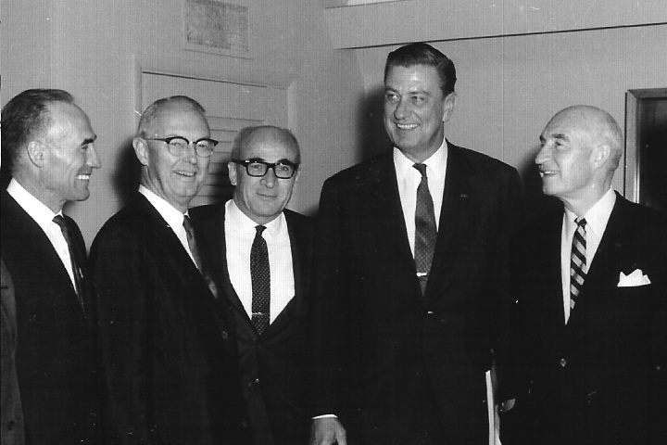
Prominent political figures were frequently guests on the "Treagle train," an excursion from Cheyenne to a UW football game in Laramie, sponsored annually by the Wyoming Tribune-Eagle newspapers. Shown here in this photograph from the middle 1960s are (left to right): Cliff Hansen, William Henry Harrison, Teno Roncalio, Franklin Roosevelt, Jr., and Milward Simpson. Roosevelt, the eldest son of FDR, had served as undersecretary of commerce in the Kennedy administration and, in the Lyndon Johnson administration, as head of the Equal Opportunity Commission.

